Lab 2 Report

Lorenz Menendez

## Report the Moran's I for the Qualification variable for Camden, using R and GeoDa.

**Using R**

Moran I statistic standard deviate = 24.292, p-value < 2.2e-16

alternative hypothesis: greater

sample estimates:

Moran I statistic Expectation Variance

0.5448699398 -0.0013368984 0.0005055733

**Using GeoDa**

0.54487

## Show a LISA map for the Qualification variable for Camden, using R and GeoDa.

**Using GeoDa**

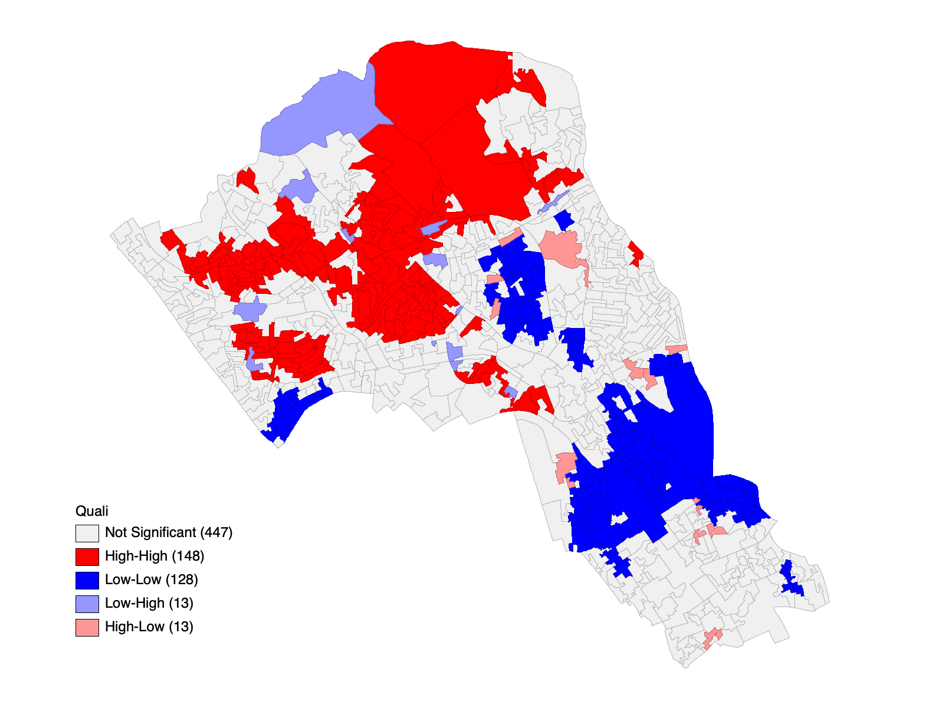

**Using R**

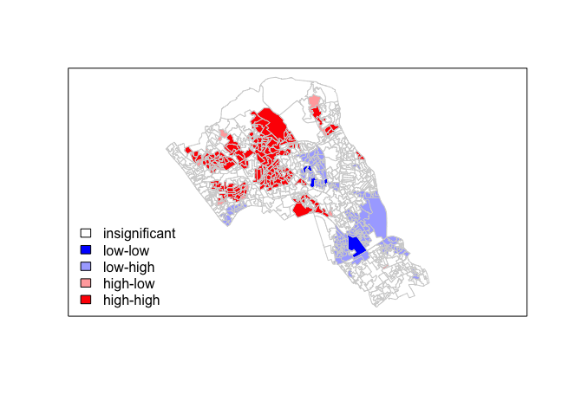

## Was there a difference between the two? Explain and discuss in detail

Yes, there’s a considerable difference between the two. The GeoDa LISA tends to report more autocorrelation (both positive and negative) than the R LISA. After reconfirming that I had the same settings in both R and GeoDa, I co cluded the following.

Specifically, the GeoDa LISA reports a much higher positive autocorrelation in North Camden compared to the R LISA. The GeoDa LISA also tends to report more isolated areas of high-high and low-low correlation compared to the R LISA.

Interestingly, the two LISAs also tend to report different correlations in multiple areas. For example, GeoDa reports a large cluster of low-low correlation in the South, while R reports it as a cluster of low-high.

## What are other options for running a Moran's I or LISA analysis in R? Investigate and provide your findings.

There are definitely other R packages out there that can run Moran’s I. A quick Google Search brought me to the “ape” packaged, recommended by UCLA’s Institute for Digital Research. However, finding another method of calculating a LISA in R in much more difficult. It seems like everyone in the R community is relying on “spdep” for their calculations.